
115 Strange Street
Kitchener
519-743-3702
warrengreenhouses@hotmail.com

Spring 2026

With spring just around the corner, pansy fund-raising is a great way to raise money for your team or organization.
Pansies are an early season flowering favourite. Tolerant to cooler weather, they can be enjoyed outside beginning in April.

We will deliver your order to the location and date of your choice. You may choose your delivery date anytime between April 6th and 19th.
There is a 100 pot minimum to qualify for free delivery within a 60 km radius. If you are beyond the radius, contact us for a delivery fee estimate.

Send in your sign up early to secure your registration and delivery date.
Please send your complete orders to us no later than March 28th.

Pansy Pots are available in MIXED colours in the following sizes.

8” Round Decorative Bowl
12” Round Decorative Bowl
11” Hanging Basket

COST Recommended Selling

8” Pot $9.00 +HST $14.00- $16.00
12” Pot $12.00 +HST $20.00- $22.00
11” Baskets $14.00 +HST $22.00- $24.00

We strive for excellent quality and service. If you encounter any problems, please notify us immediately and we will do our best to rectify the situation.
Any credit inquiries must be made within 48 hours of delivery.

Thank you and good luck!
Sheila
Pansies can be placed in sun to part sun areas and prefer to be kept moderately moist. They can withstand cold temperatures, but heavy frost or snow will damage open blooms. Best to place them undercover when frost is predicted.
Pinch spent blooms at the bottom of the stem to encourage new growth and blooming into summer months.

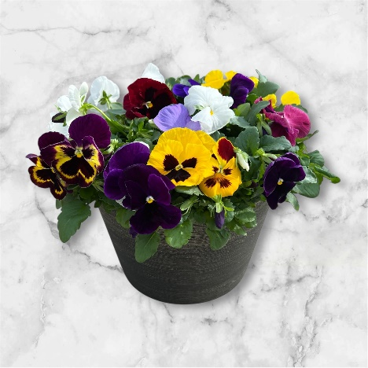
12” Round Pansy Pots

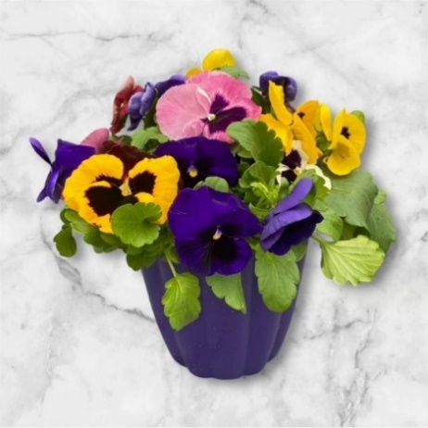
8” Round Pansy Pots

11” Cool Wave Pansy Baskets

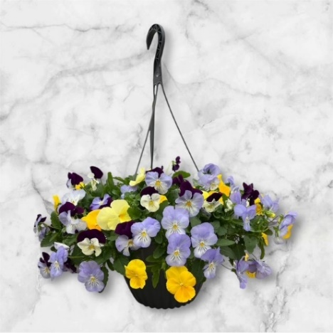


.
Pansy Fundraising Sign-Up Sheet

GROUP NAME____________________________________________

CONTACT NAME_________________________________________

DELIVERY DATE________________________TIME____________

DELIVERY ADDRESS_____________________________________

CITY__________________________ POSTAL_________________

BILLING ADDRESS ______________________________________

CITY__________________________ POSTAL__________________

PHONE NUMBER ___________________________
___________________________

EMAIL _____________________________________

I ________________________________, will be the contact person for the above-named organization and therefore will be responsible for making payment within 30 days of my delivery. 2% interest will be added to overdue invoices. We accept cheque, cash or e-transfer to; warrengreenhouses@hotmail.com

SIGNATURE_______________________________

DATE_____________________________________

